Nama: FX Bima Yudha Pratama

NIM: 205314020

Assigment About Me

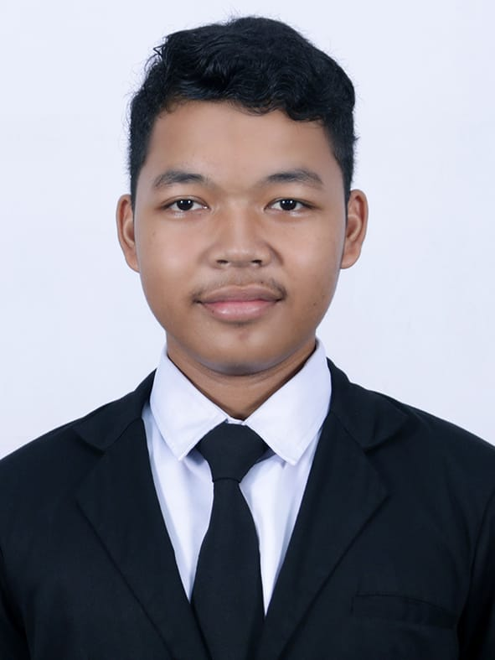

Hello miss my full name is FX Bima Yudha Pratama you can call me Yudha. I was born in Kotabumi on 20 february 2002 and then now I am 18 years old. I came from north lampung. I am a student at sanata dharma university majoring in informatics engineering. Besite that I also graduated from Yos Sudarso Senior High School on the metro city. I work hard, diligent, sometimes think critically. I good at programming on visual basic and then I good at programming on HTML and CSS. Since I was 9th grade in junior high school. I enjoy listening the music , reading novels, watching movies. I love listen music acoustic love, and ska and DJ because it makes my heart is calm and comforted especially at the moment I study home work like this assignment and working something I do. I have reading novels because when I after reading I got new words to compose especially when I study home work. And then the last I have watching movies because can make me happy after I watching them and I learn editing videos skills from movies.

I want to be a professional programmer. I also want to working in something development and I want to be teacher at senior high school after graduate. I have made a film for my final semester project with my group, and I am the one who edited my group’s film. And I edited films since middle school.